Thor-Grid VTT User Guide
Version 2.2.1

1. Introduction
Welcome to Thor-Grid Virtual Tabletop (VTT)! This application is designed to help Dungeon Masters (DMs) and players manage encounters on a grid-based map. Thor-Grid is a self-hosted Electron application, meaning one person runs the server (typically the DM), and others connect via their web browser or the Electron app itself on the same local network.
This guide covers the features available in version 2.2.1.

2. Installation
Thor-Grid is provided as executable installers for various operating systems (Windows, macOS, Linux via .deb or .rpm).
- Go to the Thor-Grid GitHub Releases page.
- Find the latest release (v2.2.1 or newer).
- Download the installer file appropriate for your operating system from the "Assets" section (e.g., .exe for Windows, .dmg for macOS, .deb for Debian/Ubuntu).
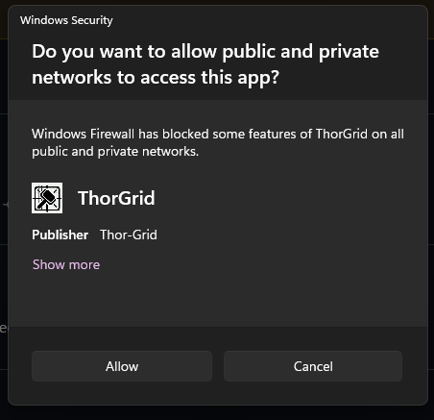
- Run the downloaded installer and follow the on-screen instructions. Be advised that you may see a one time Firewall allowance for clearing Port:4000

3. Getting Started

3.1 Running the Application
- On the Host Machine (Typically the DM):
  - Launch the Thor-Grid application like any other installed program.
  - The application will start a local web server and open a window displaying the VTT interface.
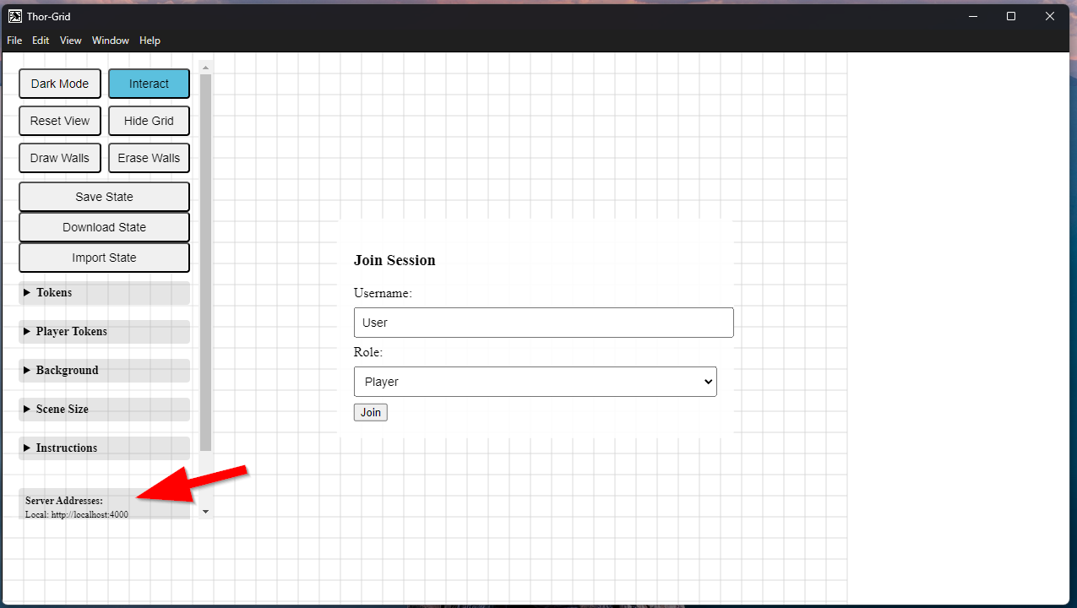
  - Check the "Server Addresses" display at the bottom of the controls panel. It will show a "Local" address (usually http://localhost:4000 for the DM's own window) and one or more "Network" addresses (like http://192.168.1.X:4000). Share one of the Network addresses that is not localhost (unless they are using the same machine as the host) with players on the same local network (Wi-Fi) so they can connect. can use to connect.

- On Player Machines:
  - Players can also install and run the Electron application, or simply use a web browser.
  - Open a web browser (Chrome, Firefox, Edge, etc.).
  - Enter one of the "Network" addresses provided by the DM into the browser's address bar and press Enter.
  - If connection is successful, the VTT interface will load.

3.2 Joining a Session (Login Screen)
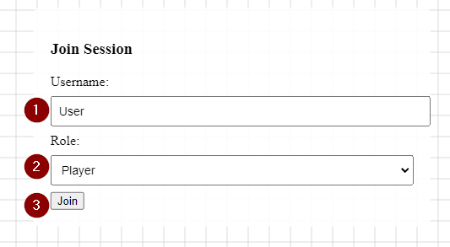
When the VTT interface loads (either in the Electron window or a browser), you will see a login screen.
- Username: Enter your desired name (e.g., your character name for players, or "DM"). The username must be unique among connected clients. If the name is already in use, you will receive an error.
- Role: Select your role from the dropdown (DM or Player).
  - The first person to log in as DM will take control of DM-specific features. If a DM is already connected, other users will only be able to join as Players.
- Click the "Join" button.
If the login is successful, the login screen will disappear, and you will see the grid interface.

3.3 Understanding the Interface Layout
- Canvas: The large central area displaying the grid, background, and tokens. This is interactive for panning, zooming, and token movement.
- Controls Panel: A panel, initially in the top-left, containing various buttons and forms for managing the game.
  - Click the "X" button in the top-right of the panel to hide it.
  - Click the "Show Controls" button (appears when hidden) to show it again.
- Login Screen: Visible only until you successfully join a session.
- Notification Area: A small box in the top-right where temporary messages (like "Connected to server!" or errors) appear.
- Server Address Display: Shows the network addresses players can use to connect." to "Shows the "Local" and "Network" addresses the server is running on. Players on the same network should use one of the Network addresses to connect.

4. Basic Interaction (All Users)
- Panning: Click and drag anywhere on the canvas not on a token while in "Interact" mode.
- Zooming:
  - Mouse: Use the mouse scroll wheel.
  - Touch: Pinch with two fingers.
- Reset View: Click the "Reset View" button in the Controls Panel to center the grid and reset the zoom level to 1x.

5. Roles: DM vs Player Capabilities
Thor-Grid has distinct capabilities based on your role:
- DM: Has full control. Can add/remove/move/rotate any token, set any token stats (HP, Init, AC, Sight, Light), draw/erase walls, load/clear backgrounds, change grid size, toggle grid visibility, save/load/import/download the game state.
- Player: Can move and rotate only the tokens they own (or owned minions), respecting wall collision. Can view the canvas based on their token's line of sight and light sources. Can view limited stats (HP/MaxHP, Init, AC, Light/Sight) for visible tokens via the context menu. Cannot access DM-only controls or manage game state.
DM-only controls are marked with the class dm-controls and are hidden for players by CSS.

6. DM Features
The DM controls are visible when logged in as DM.

6.1 Setting up the Scene
- Scene Size:
  - Expand the "Scene Size" details section.
  - Select a predefined size from the "Scene Size" dropdown. This changes the grid dimensions.
  - (Note: Changing scene size will normalize walls and clamp token positions to the new bounds).
- Background:
  - Expand the "Background" details section.
  - Enter a web URL for an image in the "Background Image URL" field and click "Load BG".
  - Alternatively, click "Or Upload Image" to select a local image file, and the app will upload it and use it as the background.
  - Click "Clear BG" to remove the background image.

6.2 Managing Tokens
- Adding Tokens:
  - Expand the "Tokens" details section.
  - Fill out the form fields:
    - Token Name: The name displayed above the token.
    - Token Image URL: A web URL for the token's image.
    - Or Upload Image: Select a local image file (overrides URL if both are provided).
    - Token Color: A fallback or solid color if no image is used (e.g., #ff0000 for red).
    - Token Size: The number of grid squares the token occupies (1x1, 2x2, etc.).
    - Token Rotation: Initial rotation in degrees (0-360).
    - Max HP / Current HP / Initiative / AC: Numerical stats for the token. Setting Max HP > 0 and Current HP < 25% of Max HP will cause the token to glow red.
    - Sight Radius (cells): How many cells away this token can see inherently (e.g., darkvision). This contributes to player visibility.
    - Is Light Source: Check this box if the token emits light.
    - Bright Range / Dim Range (cells, total): (Appears if "Is Light Source" is checked) The radius of bright light and the total radius of dim light (including bright) in cells.
    - Is Minion: Check if this token is a minion (owned by the player who adds it).
  - Click "Add Token". The token will appear in the center of the grid.
- Moving Tokens: Click and drag a token while in "Interact" mode. Tokens cannot be moved through walls .
- Rotating Tokens: Long-press (or Right-click with mouse) a token while in "Interact" mode. This opens a context menu where you can adjust the "Rotate" input field.
- Editing Token Stats/Properties (DM Only): Long-press (or Right-click with mouse) a token while in "Interact" mode. The context menu provides fields to edit Name, Rotation, Sight Radius, Light Source properties (Is Light Source, Bright Range, Dim Range) Max HP, Current HP, Initiative, and AC. Click "Save" to apply changes or "Cancel" to discard.
- Removing Tokens (DM Only): Long-press (or Right-click with mouse) a token while in "Interact" mode. Click the "Remove Token" button in the context menu.

6.3 Managing Walls
Walls block line of sight and define walkable areas (though movement is currently grid-based, walls are for visibility).
- Click the "Draw Walls" button. Your cursor changes. Click and drag across grid squares to mark them as walls.
- Click the "Erase Walls" button. Your cursor changes. Click and drag across existing wall squares to remove them.
- Click the "Interact" button or press Escape to exit wall drawing/erasing mode. Wall changes are saved automatically after you stop drawing/erasing.
- Walls block line of sight and token movement, defining walkable areas

6.4 Saving and Loading Game State
These controls allow you to save the current layout of tokens, walls, and background.
- Save State: Click "Save State" to save the current game state to a local file in your application's user data directory. This happens periodically automatically, but this allows a manual save point.
- Download State: Click "Download State" to save the current game state as a .json file to your browser's download location. This is useful for backing up or transferring states between computers.
- Import State: Click "Import State" to open a file browser. Select a previously downloaded .json state file. This will overwrite the current game state with the imported one.

7. Player Features
Players connect to the DM's running server.

7.1 Joining a Session
Use the Login Screen as described in Section 3.3, selecting the "Player" role. Use a unique username.

7.2 Understanding Visibility (Fog of War)
Players do not see the entire map clearly by default. Visibility is determined by:
- Bright Light: Areas illuminated by token bright light ranges (set by the DM) are fully visible (clear).
- Dim Light: Areas illuminated by token dim light ranges (and not in bright light) are dimly visible (partially obscured by fog).
- Player Inherent Vision: Your token's "Sight Radius" (set by the DM) allows you to know about things within that range (like the presence of tokens or walls), even in darkness. However, this vision does not visually clear the fog; the area remains obscured unless it is also illuminated by bright or dim light. Adjacent walls within your vision range will still be visible.
- Your Token's Location: The grid squares your player token occupies are always fully visible (clear).
- Walls: Walls block all types of vision and light. Adjacent walls within your vision range may be visually indicated (e.g., dimmed or colored) even when obscured by fog

7.3 Viewing Token Information
- Token Names: Names of tokens you own are always visible. Names of tokens you don't own are only visible if the token is knowable (i.e., any part of it occupies a square revealed by your bright light, dim light, or inherent vision). Names are displayed as floating labels above the tokens when zoomed in sufficiently.
- Token Glow: Token Glow: Tokens you own that are selected will glow (blue/cyan if visible). Any token (owned or not) below 25% maximum HP will have a red glow effect applied, but this glow will only be visible if the token itself is in an area revealed by bright light, dim light, or is under your own token.
- Context Menu: Long-press (or Right-click with mouse) on a token while in "Interact" mode.
  - Owned Tokens: Shows options to rotate your token. Also displays read-only HP/MaxHP, Initiative, AC, Sight Radius, and Light information (if set by DM).
  - Other Tokens: Shows limited read-only information like their HP/MaxHP, Initiative, AC, and Light ranges (if set by DM). Does not show Sight Radius for non-owned tokens.

7.4 Managing Your Tokens
- Adding Tokens: You can add tokens using the "Player Tokens" form in the Controls Panel. These tokens will automatically be assigned to you as the owner. Note that players cannot set full stats (HP, AC, Initiative) or designate tokens as light sources using this form; these are DM functions. Players can set the name, image/color, size, and rotation.Players can set the name, image/color, size, and rotation. Players cannot set HP, AC, Initiative, Sight Radius, or Light Source properties using this form; these are DM functions.
- Moving Tokens: Click and drag any token you own (or owned minions) while in "Interact" mode. You cannot move tokens through walls.
- Rotating Tokens: Long-press (or Right-click) on a token you own while in "Interact" mode and adjust the rotation in the context menu.

8. Troubleshooting
- Cannot Connect:
  - Ensure the DM has the application running.
  - Verify you are using one of the "Network" addresses provided by the DM (not the "Localhost" address unless you are on the DM's machine ).
  - Check that you are on the same local network (e.g., same Wi-Fi).
  - Firewalls can block connections. Ensure Thor-Grid is allowed through the firewall on the DM's machine, specifically for the port number shown (default is 4000).
- Username Already In Use: Choose a different username or wait for the other user with that name to disconnect.
- UI looks strange / features aren't working: Try refreshing the page (F5 in browser, View -> Reload in Electron app menu).
- Animations not working: Ensure your browser/Electron app is using hardware acceleration. This can sometimes be disabled.

